# CRM Analytics - RFM Model

## **Case Study**

A company in the e-commerce sector wants to segment its customers and determine their marketing strategies according to these segments.

**For example: If the company has a 50K marketing budget, and that amount is not enough to target everyone - How would you strategize spending this budget?**

## **Introduction to CRM**

* Customer relationship management (CRM) combines practices, strategies, and technologies that companies use to manage and analyze customer interactions and data throughout the customer lifecycle.
* CRM helps businesses to gain an insight into the behavior of their customers and modify their business operations to ensure that customers are served in the best possible way.

## **How is CRM analytics used in Business?**

* **Now that we know what CRM is - how do you think CRM analytics can be useful to this business?**
* **And more importantly, let's talk about how we can use analytics to help streamline our marketing budget with this case study?**
* CRM analytics gives insights into customers and how well the sales and customer service teams are reaching them.
* Helps analyze customers' habits to retarget and optimize sales of existing customers.
* Analyzing customers, finding audiences belonging to certain behaviors, and organizing campaigns suitable for that audience.
* CRM offers you the opportunity to improve your profitability, productivity, and efficiency.

**Customer Segmentation:**

* Imagine in a company, the marketing team will launch a campaign. For efficiency because of limited resources, it must get revenue or other metrics as much as possible.
  + This means that you need to optimize your targeting criteria so you spend more on customers that will generate more revenue for the store.
* Segmenting your customers can help you focus your marketing efforts, so you can increase profits and overall customer satisfaction
* **What are the different ways in which you feel you can group your customers to focus on?**
* Variables that are very often used for customer segmentation includes:
  + **Demographic**: Includes characteristics such as age, gender, income, education level, marital status, and occupation.
  + **Psychographic**: Includes characteristics like personality traits, lifestyle choices, social status, interests, opinions, values, and beliefs.
  + **Geographic**: Includes geographic location, such as country, region, city, climate, urban vs. rural, and population density.
  + **Behavioral**: Includes purchasing habits such as purchase frequency, average order value, product category, channel for purchasing, and brand loyalty.
* **Let's take one of these segmenting attributes and talk about how we can use this attribute to strategize our marketing budget?**

## **RFM Clustering**

* **Let's talk about another kind of segmentation - which is built from understanding the customer purchase behavior. What do you think is meant by customer purchase behavior?**
* RFM stands for **Recency**, **Frequency**, and **Monetary** **Value**.
* RFM helps the company understand the customer’s characteristics based on their historical transactions.
* To extract information about their buying behavior, we need to analyze the RFM factor.
* Then, the RFM factor for each customer would be ranked as the RFM segment for targeted marketing campaigns.

## **RFM**

* **Recency**: How recently a customer has made a purchase, either in months, days or weeks depending on your market’s typical purchase cycle?
* **Frequency:** How often a customer makes a purchase, typically measured over the twelve months leading up to each customer’s last purchase?
* **Monetary Value:** How much money a customer spends on purchase, either in-total or on-average over the same twelve month period?

## **Methodology**

* + Calculate RFM score for each customer by grouping the score for R, F & M -> 1(lowest score) & 3(highest score).
  + The lower limit and upper limit of the RFM score can be chosen by the analyst based on the data range.
  + You can use a quantile system to group the values into each score.
  + Concatenating all three scores together you get an easy way to divide-up your customers into segments (or “RFM cells”).

## **Dataset :** [**link**](https://docs.google.com/spreadsheets/d/1PTbPPvsxsbhRTFnmKoAisFqvQmjVw9AX/edit?usp=sharing&ouid=110239648225090631332&rtpof=true&sd=true)

First, we need to create a reference date for our analysis since we don’t know when this data was fetched from the database.

* Use the formula =MAX('Class Data'!$C2:$C27373) to create a new column named “Reference Date”
* Notice that here we have used Absolute References.

Now, we will get the Recency_value

* The Recency_value will be the difference (in no. of days) between the latest/reference date and the date of last purchase by the customer.
* Use the formula =H2-G2

Then, we will get the Frequency_value

* The Frequency_value will be the number of times a customer has made a purchase with us.
* Use the formula =COUNTIF($F$2:$F$27373, F2)
* Notice that we have fixed the range provided in the COUNTIF function.

Finally, we will get the Monetary_value

* The Monetary_value will be the sum of the amount spent by a customer.
* Use the formula =SUMIF($F$2:$F$27373, F2, $E$2:$E$27373)
* Notice that we have fixed the range provided in the SUMIF function.

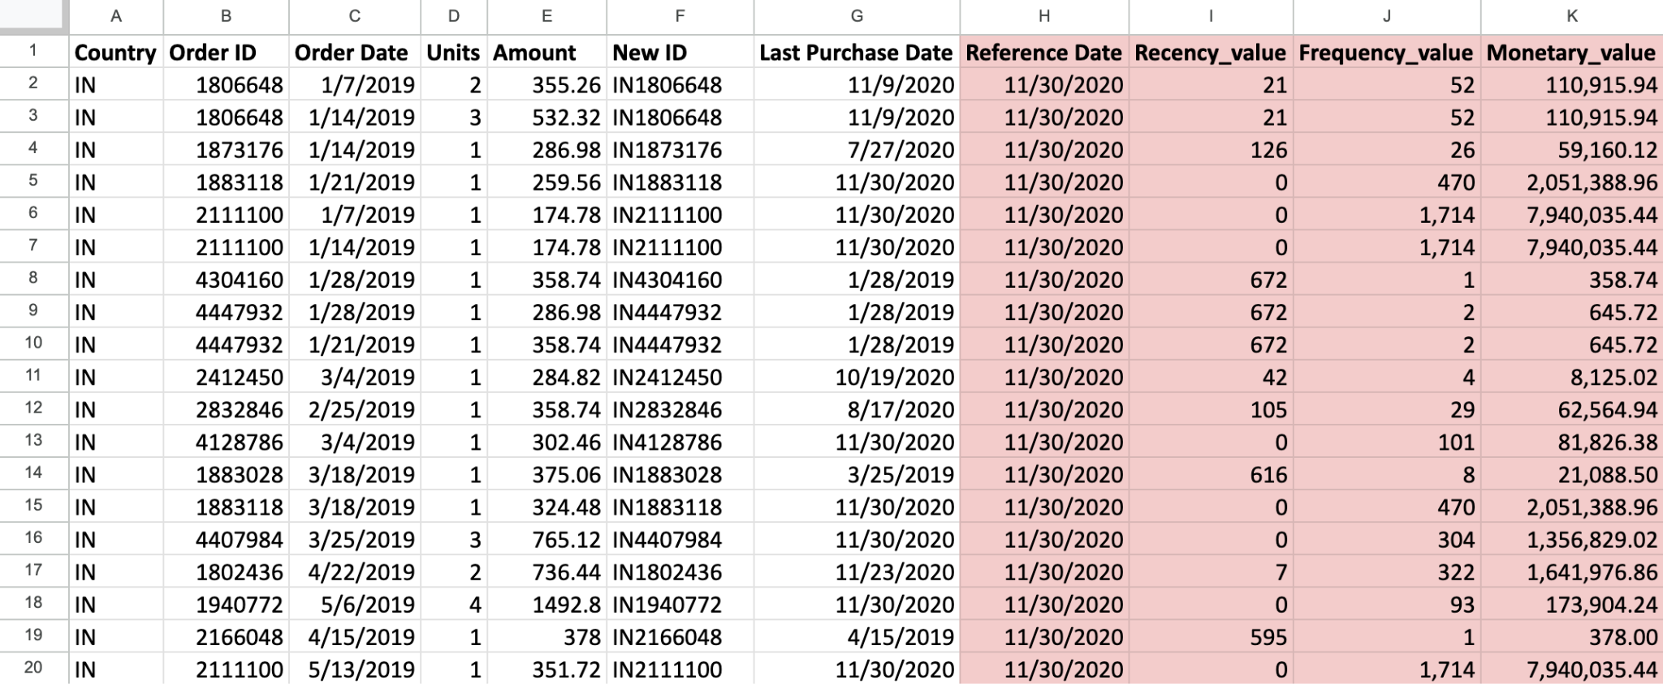

Currently our data is distributed at order level but for Customer Segmentation, we need it to be at customer level.

* Notice that the first two records have the exact same Recency, Frequency, and Monetary values.
* In order to get this data at customer level, we only need unique records (values for each customer).

To do so, we will have to create a Pivot Table.

* Insert a Pivot Table in a New sheet using the data range 'RFM Values'!A1:K27373
  + Take the New ID column and drag it to the Rows.
  + This will give you all the unique customers.
  + Notice that we have 2,013 unique customers.
* Drag the columns - Recency_value, Frequency_value, Monetary_value to Values and change the Aggregation to either Min or Max.
* Copy the Pivot Table and Paste Special as Values in a New sheet.

We’re doing this because we want to run some analysis on top of this data.

We wish to figure out who all are amongst our best customers.

* Can we say that anyone who _____ is a better customer?
  + purchased very recently
  + orders very frequently
  + spends a lot of money
* Therefore,
  + Recency - Lower is better
  + Frequency - Higher is better
  + Monetary - Higher is better

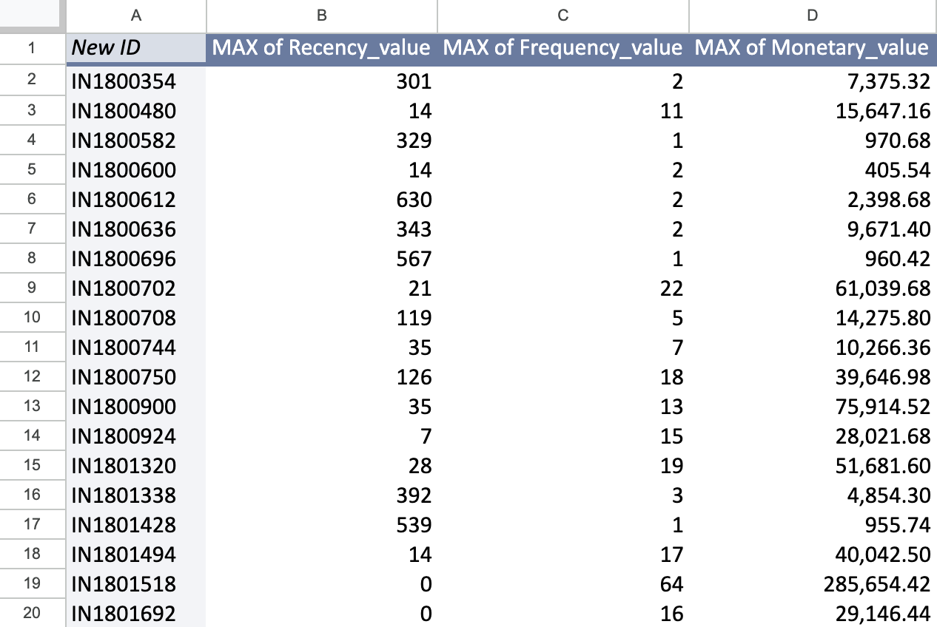

We will try to divide our customers into 3 groups. Do you recall the concept of Percentile?

1. Recency score
   1. 33% of customers have purchased within a period of less than 49 days

Use the formula =PERCENTILE.EXC(C3:C2013, 0.33)

* 1. 33% of customers made a purchase 50 to 259 days ago

Use the formula =PERCENTILE.EXC(C3:C2013, 0.66)

* 1. 33% of customers made a purchase more than 259 days ago

1. Frequency score
   1. 33% of customers have only purchased 2 times  
      Use the formula =PERCENTILE.EXC(D3:D2013, 0.33)
   2. 33% of customers have purchased between 3 to 9 times  
      Use the formula =PERCENTILE.EXC(D3:D2013, 0.66)
   3. 33% of customers have purchased more than 9 times
2. Monetary score
   1. 33% of customers have spend around $3K/-  
      Use the formula =PERCENTILE.EXC(E3:E2013, 0.33)
   2. 33% of customers have spend somewhere between $3K/- to $17K/-  
      Use the formula =PERCENTILE.EXC(E3:E2013, 0.66)
   3. 33% of customers have spend more than between $17K/-

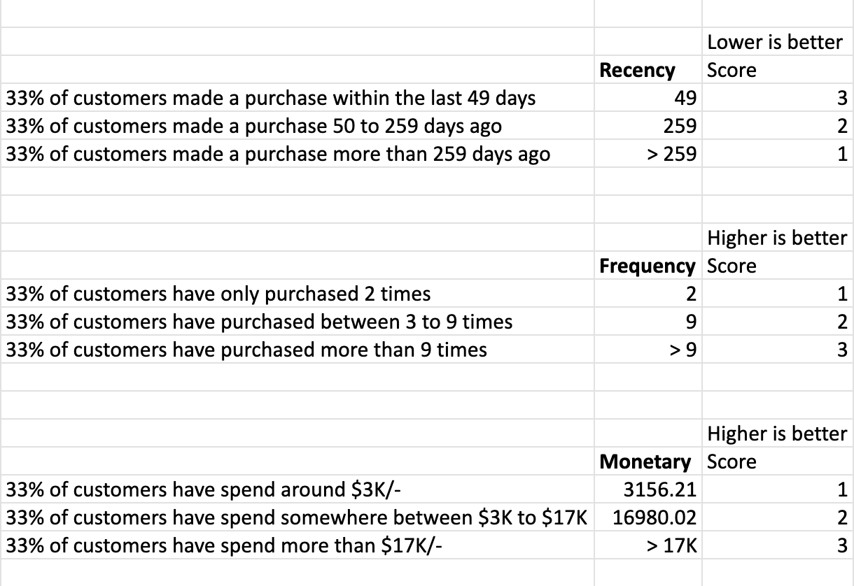

Calculating the RFM Scores -

* Create a new column named “Recency Score” using the formula =IF(C3<=$K$5, 3, IF(C3>$K$6, 1, 2))
* Create a new column named “Frequency Score” using the formula =IF(D3<=$K$12, 1, IF(D3>$K$13, 3, 2))
* Create a new column named “Monetary Score” using the formula =IF(E3<=$K$19, 1, IF(E3>$K$20, 3, 2))
* Create a new column named “RFM Score” by Concatenating the values in columns - Recency Score, Frequency Score, and Monetary Score.
  + Use the formula =CONCATENATE(F3,G3,H3)

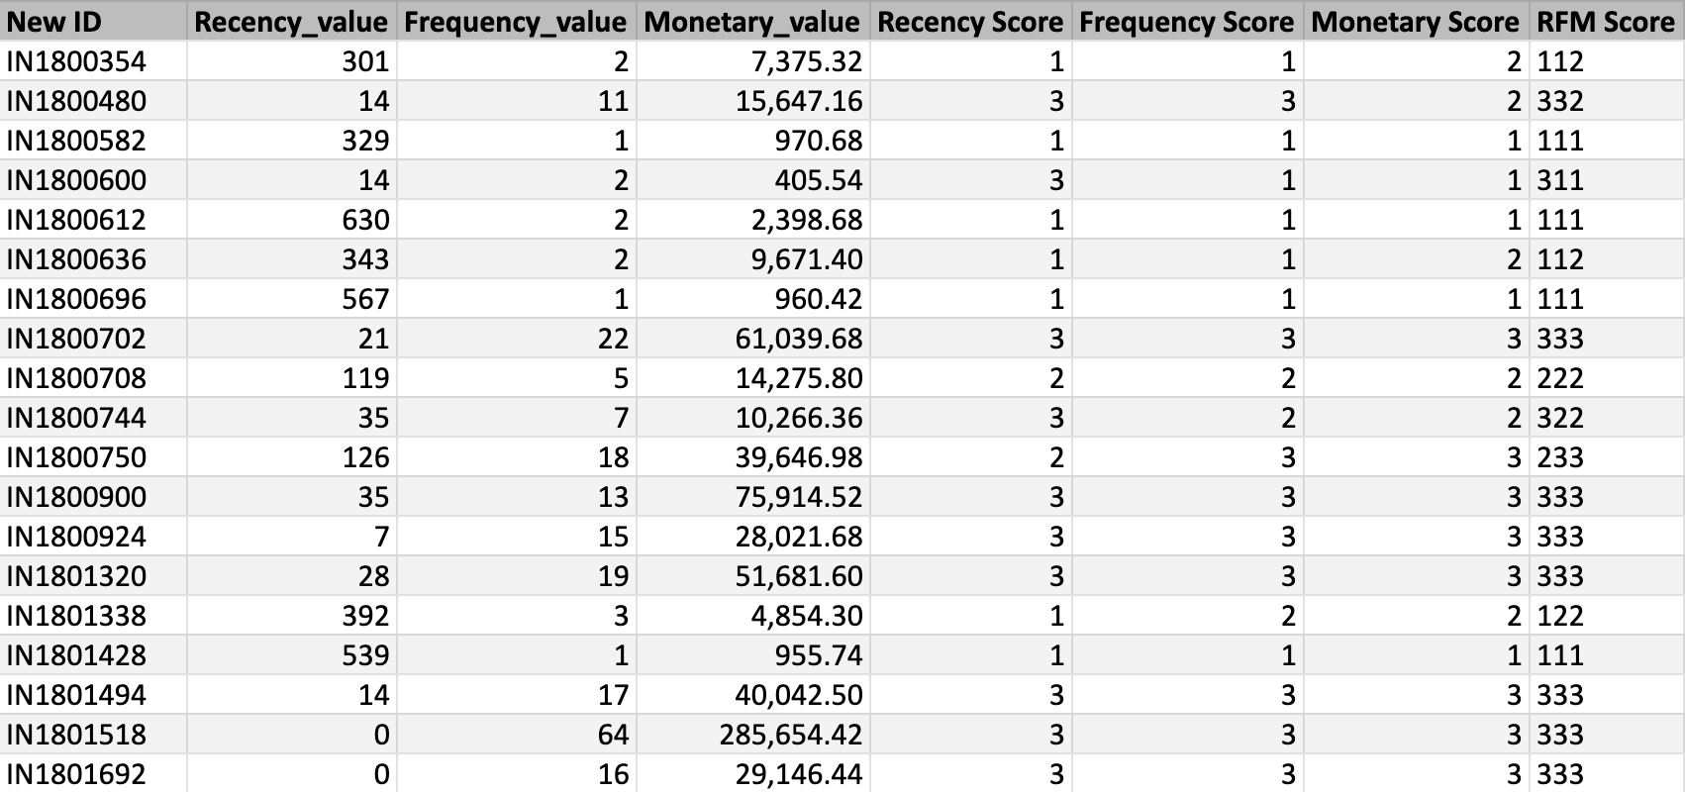

Insert another Pivot Table in a New sheet

* Take the RFM Score column and drag it to the Rows.
* Drag the column - New ID to Values and change the Aggregation to COUNT.

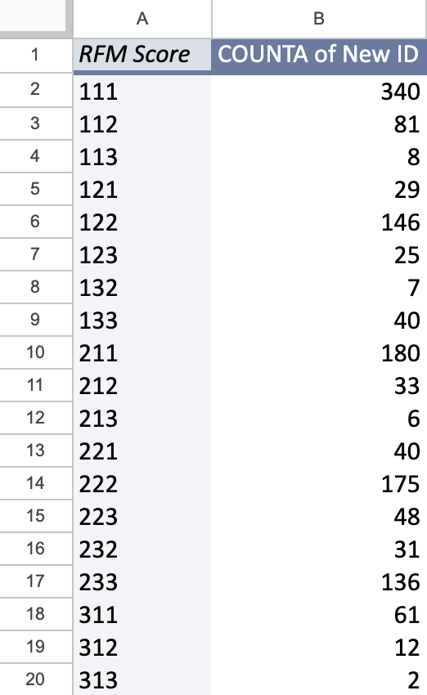

## **Customer Segments/Profiles**

**Let's talk about how we can use these RFM scores to formulate strategies for the various customer profiles.**

* **We know in this specific use case we rate R, F & M from 1-3. 1 being lowest and 3 being highest.**
* **If we want to target high-spending new purchasers, what RFM scores would we be looking for?**
* high-spending new purchasers (313, 3 for recency, 1 for frequency and 3 for monetary value) -
  + Recency (High) - Since they are new purchasers
  + Frequency (Low) - Since they are new purchasers so they have just started purchasing
  + Monetary (High) - Since they are high spending customers

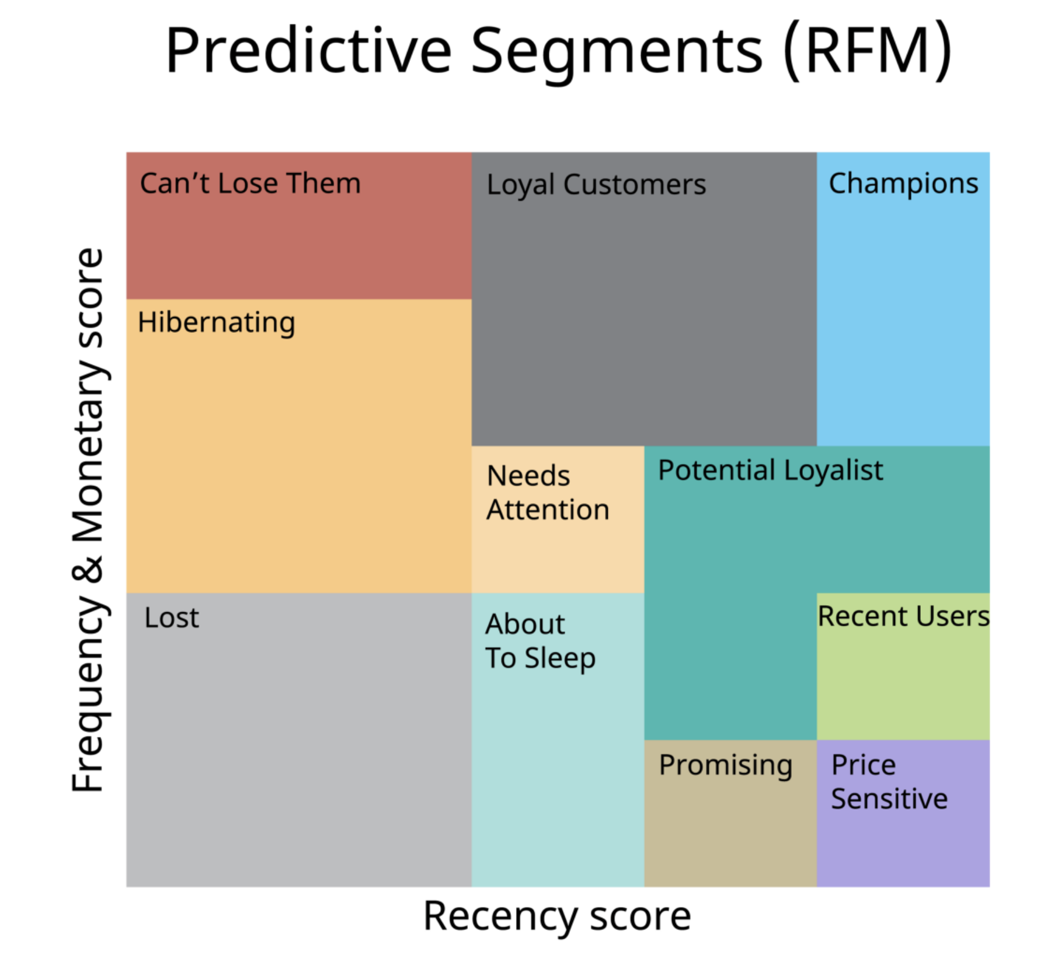

* **Can’t lose them:** This is the customer class that should not be lost, who has not shopped for a long time despite shopping very often before.
* **Hibernating / At Risk:** The class of customers who shop relatively often but have not shopped for a long time.
* **About to sleep:** This is the customer class who has not shopped frequently and has passed a certain amount of time since their shopping.
* **Need attention:** It is the customer class in the middle of the RF graph, and if it is not emphasized, it moves towards the risky group.
* **Price Sensitive / New customers:** It is the customer class who has not made frequent purchases (perhaps once) and has passed a short time since their purchase.
* **Promising:** They are customers who do not shop frequently, and a little time has passed since their shopping.
* **Potential loyalists:** Customers who shop at medium frequency and have not spent a long time since their last purchase.
* **Loyal customers:** Customers who shop frequently and whose last purchase has been a short while.
* **Champions:** They are our apple of the eye! They are customers who shop frequently and have made their last purchases in a very short time.

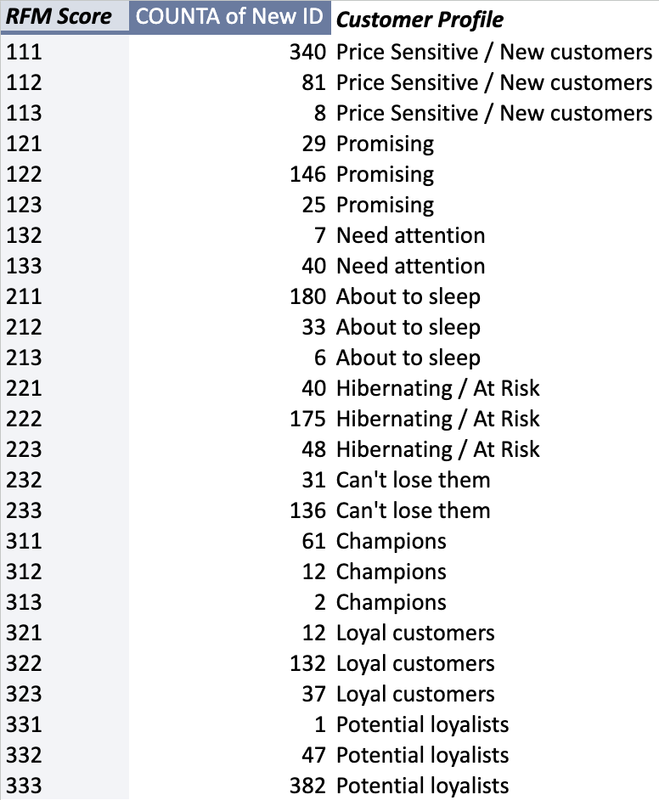

## **Use Case of RFM in context of an E-commerce website (e.g. Amazon)**

1. **High-RFM Customers:**
   1. These are Amazon's most valuable customers. They have made a purchase within the last 30 days, place orders very frequently, and have spent a significant amount.
   2. Amazon should provide them with the most personalized and exclusive offers:
      1. Personalized Recommendations: Amazon's recommendation engine can offer these customers highly personalized product recommendations based on their previous purchases and browsing history.
      2. Exclusive Access: Offer early access to new product releases or limited-time, high-demand items.
      3. Premium Loyalty: Invite them to join premium loyalty programs like Amazon Prime with additional benefits, such as faster shipping and exclusive content access.
2. **Moderate-High-RFM Customers:**
   1. These customers are also valuable but might need slightly less aggressive marketing.
   2. Amazon can consider the following strategies:
      1. Personalized Product Recommendations: Provide tailored product recommendations based on their purchase history, but perhaps with slightly fewer promotional emails.
      2. Loyalty Rewards: Offer loyalty rewards, like Amazon gift cards or discounts, as incentives for continued engagement.
      3. Early Access: Provide early access to certain deals or promotions to maintain their engagement.
3. **Moderate-RFM Customers:**
   1. These customers are engaged but may need encouragement to increase their frequency and spending.
   2. Amazon can target them with relevant promotions and engagement campaigns:
      1. Product Bundles: Create product bundles or kits to encourage additional purchases.
      2. Time-Limited Promotions: Offer time-limited promotions, such as "buy one, get one at a discount" or "spend a certain amount and receive a gift."
      3. Re-engagement Emails: Send personalized emails that remind customers of their past shopping experiences and provide incentives to make another purchase.
4. **Moderate-Low-RFM Customers:**
   1. These customers are at risk of becoming inactive.
   2. Amazon can implement win-back campaigns and special incentives to keep them engaged:
      1. Win-Back Campaigns: Send targeted emails with attractive discounts or special offers to encourage them to return to the platform.
      2. Abandoned Cart Reminders: Use reminders for items left in the cart to prompt them to complete their purchase.
      3. Personalized Suggestions: Suggest products or categories they have shown interest in previously.
5. **Low-RFM Customers:**
   1. These are the most challenging groups, but they still have potential.
   2. Amazon can use targeted re-engagement efforts:
      1. Customer Surveys: Send surveys to gather feedback on their shopping experiences and preferences. Use this feedback to make improvements and offer more personalized product suggestions.
      2. Special Promotions: Provide compelling promotions or incentives to entice them back to Amazon, such as discounts on their next purchase or free shipping on a minimum order amount.

By applying the RFM framework to different customer segments, Amazon can effectively tailor its marketing and engagement strategies to maximize customer retention, reactivation, and overall customer lifetime value.